# Task A

## The aim of the website.

The aim of the website is to provide the website guest with information and advice when planning his/her stay in Cork and what to see and do when he/she arrives.

## Customer requirements.

The customer requires that the website opens and functions properly in Microsoft Internet Explorer and Google Chrome. The website should consist of five web pages and navigation links between all five web pages must work allowing user to freely navigate the site. The website must contain an email link, two interactive features and at least one animation.

Website should contain following pages:

* Home,
* Stay,
* Eat & Drink,
* About,
* Contact.

Home page will welcome the user to Cork and provide him/her with information about upcoming events and things to see, to do or to experience when in Cork.

Stay page should provide the user with information about available accommodation in Cork and should at least consist of two guesthouses and two hotels. Each place should have the name, short description, address, contact number, email and website listed. There should be a photograph for each establishment.

Eat & Drink page should list at least two cafes, wine bars, restaurants and pubs. Each place should have the name, short description, address, contact number, email and website listed. There should be a photograph for each establishment.

The About page should consist of a few paragraphs about Cork. It should also provide info about Cork’s history. Page should describe how to get to Cork and provide info about the weather.

Contact page should give user the information about Cork’s Tourist Office including the name, address, contact number and email address. It should also allow user to make enquiries using a form. The form should allow user to enter their name and email. User should be able to select an enquiry category from the following:

* Information request,
* Website changes,
* Events or news
* Other.

User should be able to enter the subject, the message and use submit button to submit the enquiry form using email.

## Site layout

Hand drawn page layouts.

## Site Style

### Home page styling

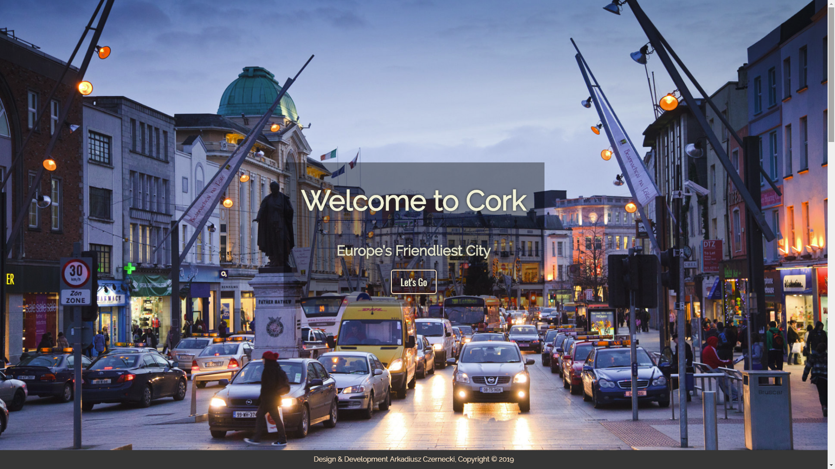

Background image (cover)

.intro{

height: 100vh;

width: 100%;

margin: auto;

background: url('../images/cork-ps.jpg') no-repeat;

display: table;

background-size: cover;

background-position: center;

}

Animated container

.welcome .animated{

position: relative;

animation: slideIn;

animation-duration: 4s;

animation-fill-mode: forwards;

padding: 40px;

background: rgba(0, 0, 0, 0)

}

@keyframes slideIn{

0% {bottom: -1000px}

40% {bottom: 30px;

background: rgba(0, 0, 0,0.0)}

100% {bottom: 0px;

background: rgba(0, 0, 0,0.4);

}

}

Welcome text and button style

.welcome h1{

font-family: 'Raleway', sans-serif;

color: rgba(243, 241, 219,1);

text-shadow: 0px 0px 10px #333;

font-size: 400%;

text-align: center;

text-justify: unset;

padding: 0px;

margin-top: 0px;

}

.welcome h3{

font-family: 'Raleway', sans-serif;

color: rgba(243, 241, 219,0.9);

text-shadow: 0px 0px 10px #333;

font-size: 200%;

text-align: center;

text-justify: unset;

padding: 0px;

margin-top: 0px;

margin-bottom: 1em;

}

.welcome .btn{

border-radius: 6px;

font-family: 'Oswald', sans-serif;

color: rgb(243, 241, 219);

font-size: 135%;

padding: 10px 20px;

border: solid rgb(255, 230, 205) 2px;

text-decoration: none;

text-shadow: 0px 0px 5px #333;

box-shadow: 0px 0px 15px #333;

}

.welcome .btn:hover{

color: white;

border: solid white 2px;

}

### General page styling

html{

margin: 0;

padding: 0;

font-family: Arial,sans-serif;

font-size: 1rem;

line-height: 1.5;

-webkit-font-smoothing: antialiased;

}

### Header styling



h1, h2, h3, h4, h5{

font-family: 'Raleway', sans-serif;

color: rgb(10, 83, 126);

}

### Info card style

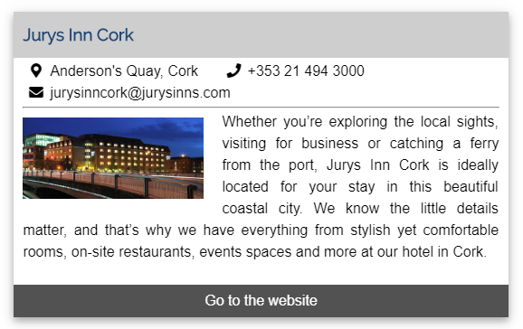

.infoHolder .card{

width:70%;

margin: auto;

margin-bottom: 30px;

box-shadow:0 4px 10px 0 rgba(0,0,0,0.2),0 4px 20px 0 rgba(0,0,0,0.19);

}

.infoHolder header{

display: flex;

background-color: lightgray;

}

.infoHolder header h3{

margin-top: .6em;

margin-bottom: .6em;

padding: 0px 10px;

}

.infoHolder .cardContent{

padding: 0px 10px;

}

.infoHolder div p{

margin-top: .2em;

margin-bottom: .0em;

}

.infoHolder hr{

margin: 0px;

padding: 0px 10px;

}

.infoHolder img{

float: left;

width: 200px;

margin: 10px 0px;

margin-right: 20px;

}

.infoHolder > div > div:last-child a:last-child{

display: block;

background-color: rgb(90, 90, 90);

color: white;

text-decoration: none;

text-align: center;

padding: 6px 0px;

}

.infoHolder > div > div:last-child a:last-child:visited {

color: white;

}

.infoHolder > div > div:last-child a:last-child:not(.active):hover {

background-color: rgba(70, 70, 70, 1);

}

.infoHolder > div > div > p:last-of-type{

text-align: justify;

text-justify: auto;

}

.infoHolder > div > div p:nth-child(-n+2){

text-align: left;

}

.infoHolder > div > div p:nth-child(-n+2) a{

color: black;

margin-right: 20px;

text-decoration: none;

display: inline-block;

}

.infoHolder > div > div p:nth-child(-n+2) a:visited{

color: black;

}

.infoHolder > div > div p:nth-child(-n+2) a:hover{

color: red;

}

.infoHolder > div > div p:nth-child(-n+2) > a > i{

width: 30px;

text-align: center;

}

.clearfix {

overflow: auto;

}

### Form Style

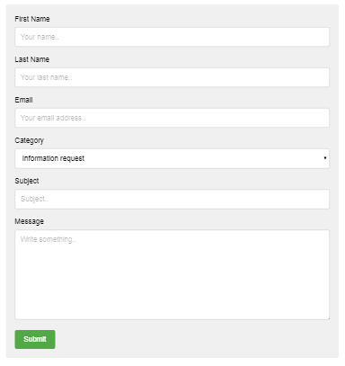

form{

width: 90%;

margin: auto;

border-radius: 5px;

background-color: #f2f2f2;

padding: 20px;

}

form ::placeholder{

color: rgba(0, 0, 0, .3);

}

input[type=text], input[type=email], select, textarea {

width: 100%;

padding: 12px;

border: 1px solid #ccc;

background-color: white;

border-radius: 4px;

box-sizing: border-box;

margin-top: 6px;

margin-bottom: 16px;

resize: vertical;

}

.submit {

background-color: #4CAF50;

color: white;

padding: 12px 20px;

border: none;

border-radius: 4px;

cursor: pointer;

}

.submit:hover {

background-color: #45a049;

}

## Site Map

## Timescale for completing the website

Webpage should be completed by 12:30 pm, Tue 12th Feb 2019.